**PRACTICAL NO – 1**

**INTRODUCTION DESCRIPTION AND TO WIKIPEDIA**

**NAME – Gunja Singh**

**ROLL NO – 88**

**CLASS – FYIT**

**1)DESCRIPTION ABOUT WIKIPEDIA AND ITS FEATURE**

**DESCRIPTION :**

Wikipedia was launched on January 15, 2001 by [Jimmy Wales](https://en.wikipedia.org/wiki/Jimmy_Wales" \o "Jimmy Wales) and [Larry Sanger](https://en.wikipedia.org/wiki/Larry_Sanger" \o "Larry Sanger). Sanger coined its name as a [portmanteau](https://en.wikipedia.org/wiki/Portmanteau" \o "Portmanteau) of "[wiki](https://en.wikipedia.org/wiki/Wiki" \o "Wiki)" and "[encyclopedia](https://en.wikipedia.org/wiki/Encyclopedia" \o "Encyclopedia)". It was initially an [English-language encyclopedia](https://en.wikipedia.org/wiki/English_Wikipedia" \o "English Wikipedia), but versions in [other languages](https://en.wikipedia.org/wiki/List_of_Wikipedias" \o "List of Wikipedias) were quickly developed. With 6.2 million articles, the English Wikipedia is the largest of the 317 Wikipedia encyclopedias. Overall, Wikipedia comprises more than 55 million articles, attracting 1.7 billion unique visitors per month.

**FEATURES** **:**

Wikipedia [has been criticized](https://en.wikipedia.org/wiki/Criticism_of_Wikipedia" \o "Criticism of Wikipedia) for its uneven accuracy and for exhibiting [systemic bias](https://en.wikipedia.org/wiki/Criticism_of_Wikipedia" \l "Systemic_bias_in_coverage" \o "Criticism of Wikipedia), including [gender bias](https://en.wikipedia.org/wiki/Gender_bias_on_Wikipedia" \o "Gender bias on Wikipedia), with the majority of editors being [male](https://en.wikipedia.org/wiki/Male" \o "Male) [Edit-a-thons](https://en.wikipedia.org/wiki/Edit-a-thon" \o "Edit-a-thon) have been held to encourage female editors and increase the coverage of women's topics. In 2006, *[Time](https://en.wikipedia.org/wiki/Time_(magazine)" \o "Time (magazine))* magazine stated that the open-door policy of allowing anyone to edit had made Wikipedia the biggest and possibly the best encyclopedia in the world, and was a testament to the vision of Jimmy Wales. The project's reputation improved further in the 2010s as it increased efforts to improve its quality and reliability, based on its unique structure, curation and absence of commercial bias. In 2018, [Facebook](https://en.wikipedia.org/wiki/Facebook" \o "Facebook) and [YouTube](https://en.wikipedia.org/wiki/YouTube" \o "YouTube) announced that they would help users detect [fake news](https://en.wikipedia.org/wiki/Fake_news" \o "Fake news) by suggesting links to related Wikipedia articles

**2)CREATING ACCOUNT ON WIKIPEDIA**

**STEP 1 :** Fill all your details in the given space and enter the captcha

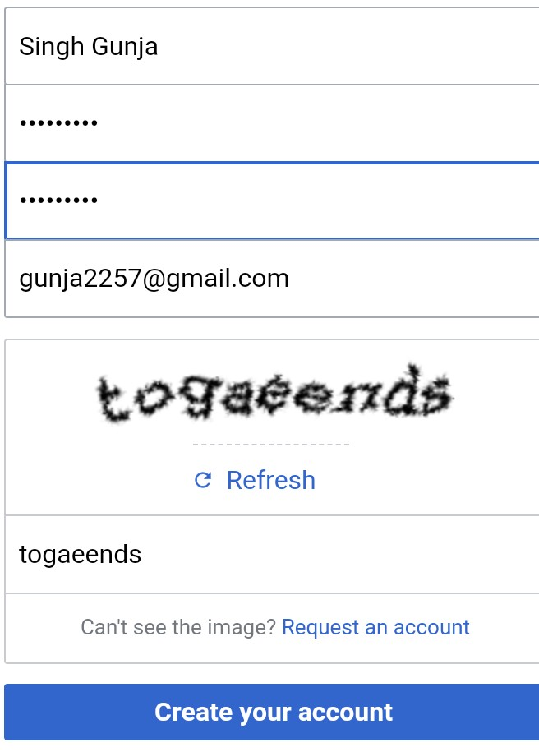

**STEP 2 : Verify your email account**

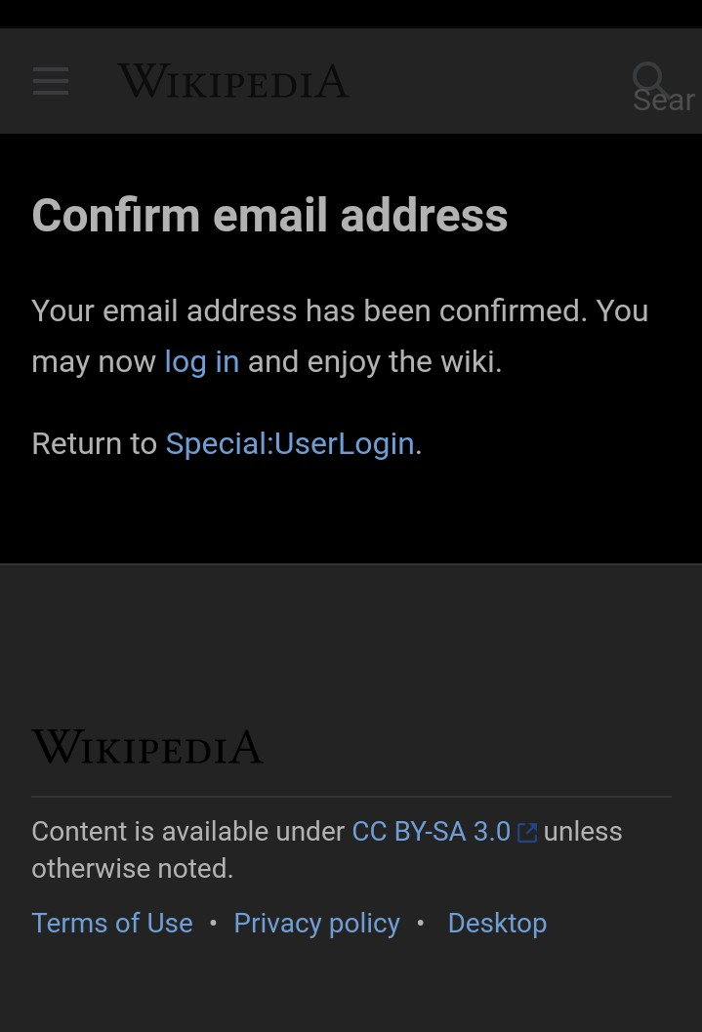

**STEP 3 : This is the created page**

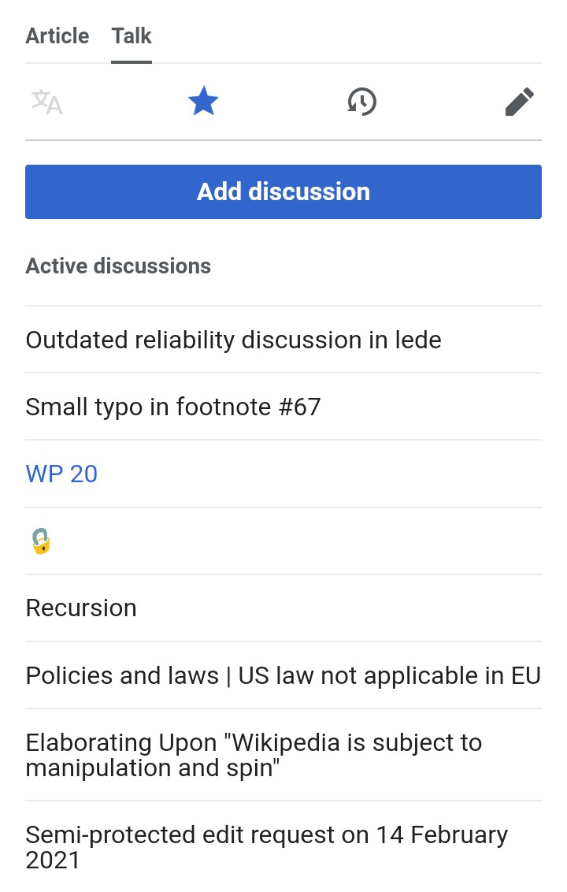

**3) CREATING YOUR PAGE ON WIKIPEDIA**

**STEP 1 :** Click on user page to create your own pag

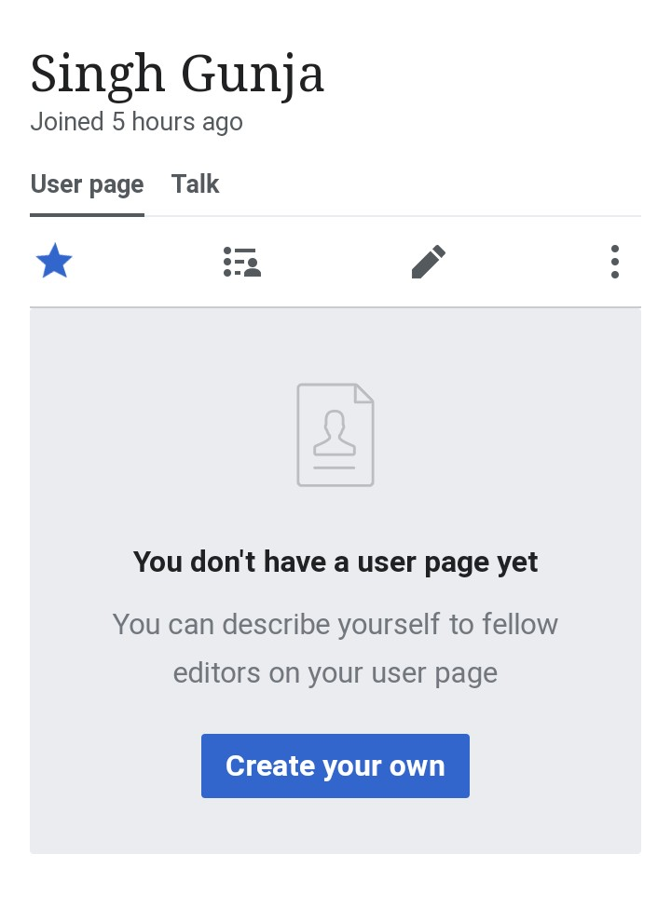

**STEP 3 :** Publish your page after making it

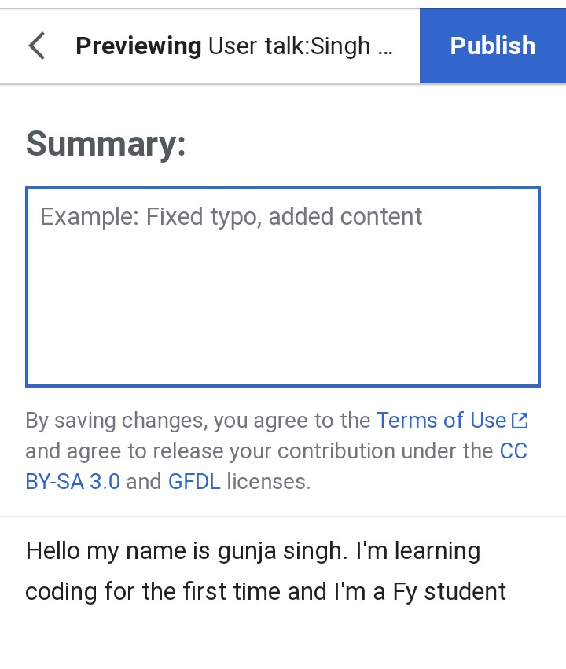

**4) EDITING YOUR PAGE ON WIKIPEDIA**

**STEP 1 :** We can edit or change our page after publishing it by click on edit page

